[https://www.sciencedirect.com/referencework/9780128160978/encyclopedia-of-the-worlds-biomes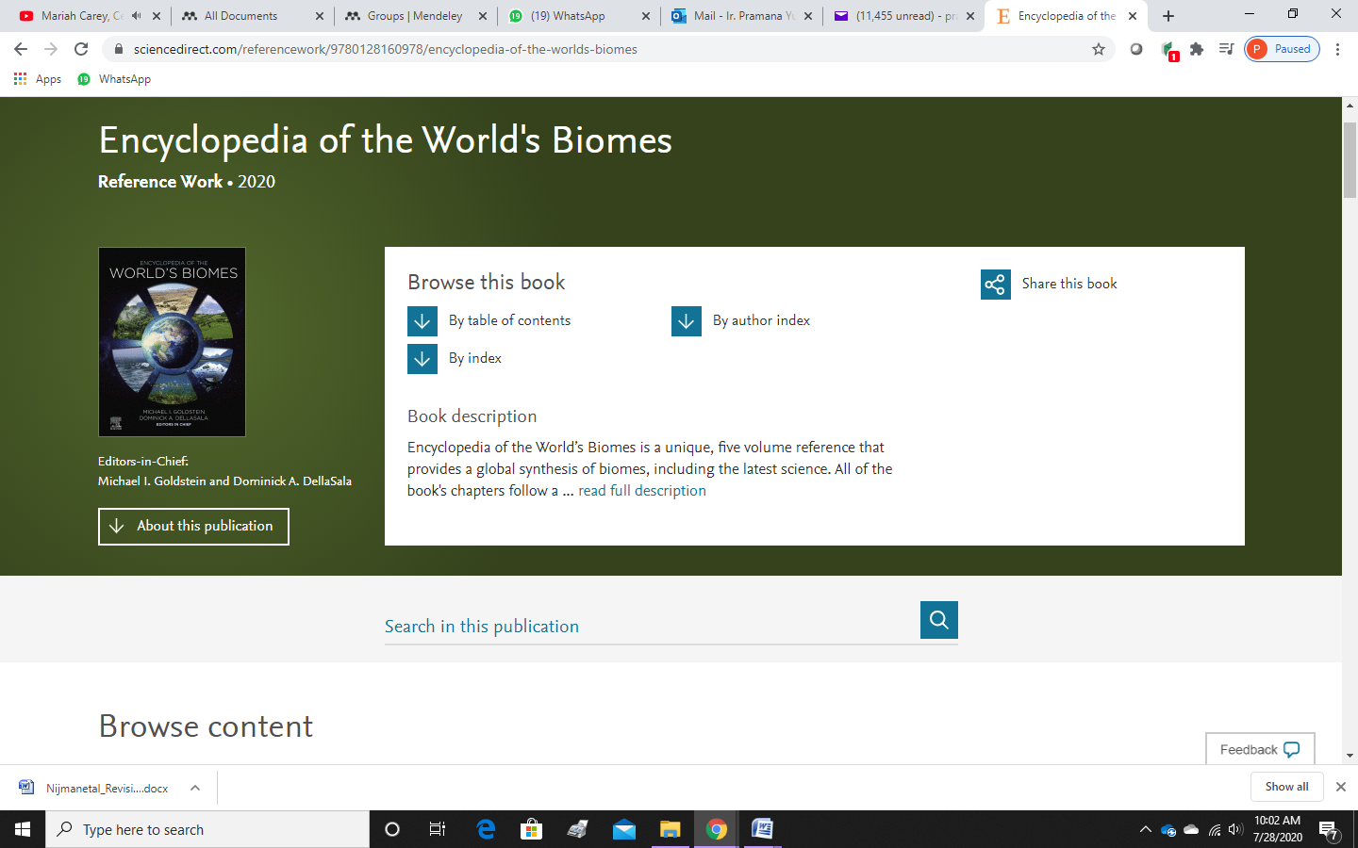](https://www.sciencedirect.com/referencework/9780128160978/encyclopedia-of-the-worlds-biomes#)

